Report:

We tried to build different models choosing different hyperparameters which decide the performance of the model. We tabuled those values below

Tanh_activation

Building a model with regularization function with tanh activation. This has three hidden layers with 64,32,16 units respectively.

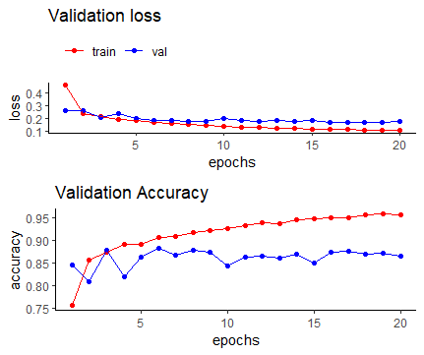

From the above graph it is hard to state from where the model is getting over fitted so choosing epoch value is difficult in this model. By this we can say that this model is not stable.

Relu_activation

Building a model with regularization function with relu activation. This has three hidden layers with 64,32,16 units respectively.

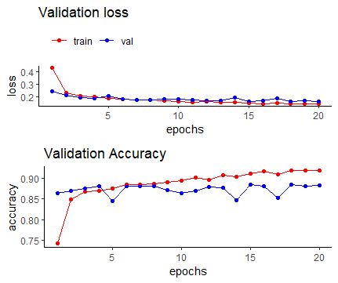

When we used relu function the model is stable and can be distinguished clearly where the model is getting over fitted.

Conclusion:

We examined above models with tanh and relu activation functions using different layers. By observations we can clearly distinguish where the model is getting over fitted using relu activation function where as in tanh it is hard to find where the model is getting over fitted.